A000-ME-Iran-Jiroft-Chalice-Chlorite-Kerman Bronze Age I, 2500 BCE

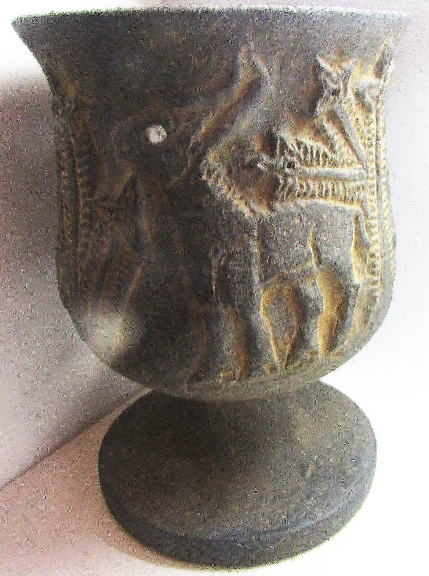 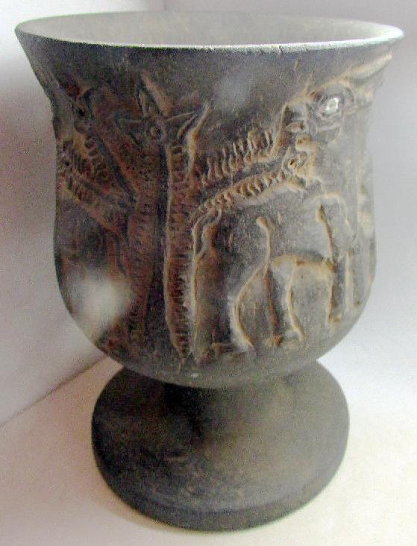 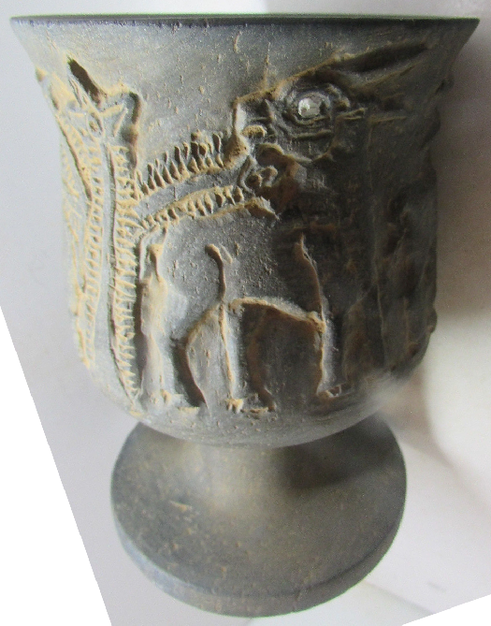 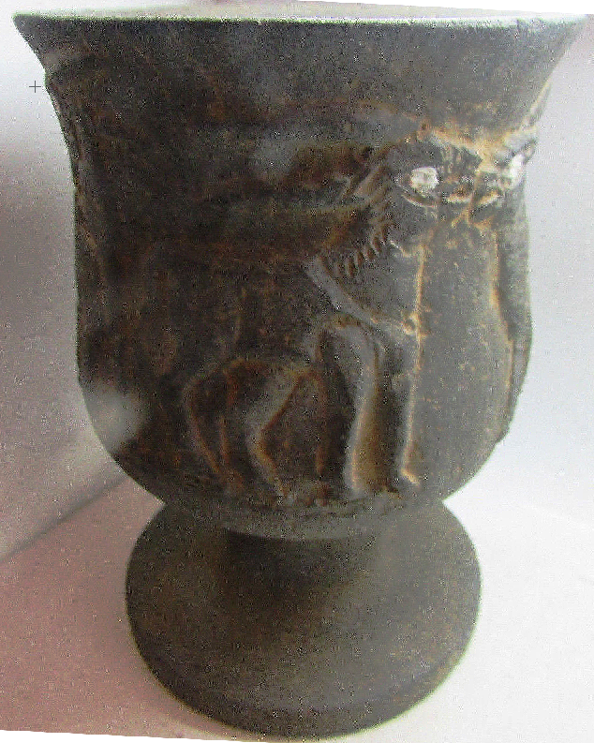 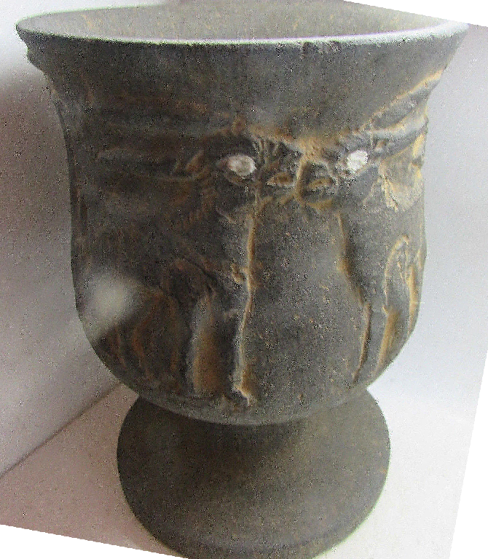

Figs. 1-5. A000-ME-Iran-Jiroft-Chalice-Chlorite-Kerman Bronze Age I, 2500 BCE

14.7 CM HIGH

**Case No.: 2**

**Accession No.**

**Formal Label:** A000-ME-Iran-Jiroft-Chalice-Chlorite-Kerman Bronze Age I, 2500 BCE

**The** early Bronze Age, late 3rd millennium BCE  **Jiroft** archaeological culture [[1]](https://en.wikipedia.org/wiki/Jiroft_culture#cite_note-1)  is located in [Balochistan](https://en.wikipedia.org/wiki/Balochistan) and [Kermān Provinces](https://en.wikipedia.org/wiki/Kerm%C4%81n_Province" \o "Kermān Province) of [Iran](https://en.wikipedia.org/wiki/Iran). [Konar Sandal](https://en.wikipedia.org/wiki/Konar_Sandal), near [Jiroft](https://en.wikipedia.org/wiki/Jiroft" \o "Jiroft) in the [Halil River](https://en.wikipedia.org/wiki/Halil_River" \o "Halil River) area. Other significant sites associated with the culture include; [Shahr-e Sukhteh](https://en.wikipedia.org/wiki/Shahr-e_Sukhteh" \o "Shahr-e Sukhteh) (Burnt City), [Tepe Bampur](https://en.wikipedia.org/w/index.php?title=Tepe_Bampur&action=edit&redlink=1" \o "Tepe Bampur (page does not exist)), [Espiedej](https://en.wikipedia.org/w/index.php?title=Espiedej&action=edit&redlink=1" \o "Espiedej (page does not exist)), [Shahdad](https://en.wikipedia.org/wiki/Shahdad" \o "Shahdad), [Tal-i-Iblis](https://en.wikipedia.org/w/index.php?title=Tal-i-Iblis&action=edit&redlink=1) and [Tepe Yahya](https://en.wikipedia.org/wiki/Tepe_Yahya" \o "Tepe Yahya).

The proposition of grouping these sites as an "independent [Bronze Age](https://en.wikipedia.org/wiki/Bronze_Age) [civilization](https://en.wikipedia.org/wiki/Civilization) with its own architecture and language, intermediate between [Elam](https://en.wikipedia.org/wiki/Elam) to the west and the [Indus Valley Civilization](https://en.wikipedia.org/wiki/Indus_Valley_Civilization) to the east, is due to [Yusef Majidzadeh](https://en.wikipedia.org/wiki/Yusef_Majidzadeh" \o "Yusef Majidzadeh), head of the archaeological excavation team in [Jiroft](https://en.wikipedia.org/wiki/Jiroft" \o "Jiroft). He speculates they may be the remains of the lost [Aratta](https://en.wikipedia.org/wiki/Aratta" \o "Aratta) Kingdom, but his conclusions have met with skepticism from some reviewers. Other conjectures (e.g. Daniel T. Potts, Piotr Steinkeller) have connected the [Konar Sandal](https://en.wikipedia.org/wiki/Konar_Sandal" \o "Konar Sandal) with the obscure city-state of [Marhashi](https://en.wikipedia.org/wiki/Marhashi" \o "Marhashi), that apparently lay to the east of [Elam](https://en.wikipedia.org/wiki/Elam) proper.

Discovery and excavation[[edit](https://en.wikipedia.org/w/index.php?title=Jiroft_culture&action=edit&section=1" \o "Edit section: Discovery and excavation)]

Many artifacts associated with Jiroft were recovered from looters described as "destitute villagers" who had scavenged the area south of [Jiroft](https://en.wikipedia.org/wiki/Jiroft" \o "Jiroft) before 2001, when a team led by [Yusef Majidzadeh](https://en.wikipedia.org/wiki/Yusef_Majidzadeh" \o "Yusef Majidzadeh) began excavations. The team uncovered more than two square kilometers of remains from a city dating back to at least the late 3rd millennium BCE. The data Madjidzadeh's team has gathered demonstrates that Jiroft's heyday was from 2500 BC to 2200 BC.[[2][2]](https://en.wikipedia.org/wiki/Jiroft_culture#cite_note-archaeology.org-2)

The looted artifacts and some vessels recovered by the excavators were of the so-called "intercultural style" type of pottery known from Mesopotamia and the Iranian Plateau, and since the 1960s from nearby [Tepe Yahya](https://en.wikipedia.org/wiki/Tepe_Yahya" \o "Tepe Yahya) in Baft. The "Jiroft civilization" hypothesis proposes that this "intercultural style" is in fact the distinctive style of a previously unknown, long-lived civilization.[*[citation needed](https://en.wikipedia.org/wiki/Wikipedia:Citation_needed" \o "Wikipedia:Citation needed)*]

[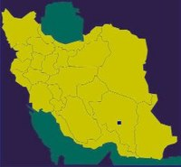](https://en.wikipedia.org/wiki/File:Jiroft.Iran.jpg)

location of Jiroft in Iran

This is not universally accepted. Archaeologist [Oscar Muscarella](https://en.wikipedia.org/wiki/Oscar_Muscarella) of the [Metropolitan Museum of Art](https://en.wikipedia.org/wiki/Metropolitan_Museum_of_Art) criticizes that the excavators resorted to sensationalist announcements while being more slow in publishing scholarly reports, and their claims that the site's [stratigraphy](https://en.wikipedia.org/wiki/Stratigraphy) shows continuity into the 4th millennium as overly optimistic. Muscarella does nevertheless acknowledge the importance of the site.

Earlier excavations at [Kerman](https://en.wikipedia.org/wiki/Kerman) were conducted by [Sir Aurel Stein](https://en.wikipedia.org/wiki/Marc_Aurel_Stein) around 1930.

One of the most notable archaeological excavations done in [Kerman Province](https://en.wikipedia.org/wiki/Kerman_Province) was one done by a group led by Professor [Joseph Caldwell](https://en.wikipedia.org/wiki/Joseph_Caldwell) from [Illinois State Museum](https://en.wikipedia.org/wiki/Illinois_State_Museum) in 1966 (Tal-i-Iblis) and [Lamberg-Karlovsky](http://www.fas.harvard.edu/~anthro/karlovsky) from [Harvard University](https://en.wikipedia.org/wiki/Harvard_University) in 1967 (Tepe Yahya [Sogan Valley](https://en.wikipedia.org/w/index.php?title=Sogan_Valley&action=edit&redlink=1" \o "Sogan Valley (page does not exist)), [Dolatabad](https://en.wikipedia.org/wiki/Dolatabad" \o "Dolatabad)).

Archeological excavations in Jiroft led to the discovery of several objects belonging to the fourth millennium BCE.

According to Majidzadeh, geophysical operations by French experts in the region indicate the existence at least 10 historical and archaeological periods in the region belonging to different civilizations who lived in this area during different periods of time in history. According to the [French](https://en.wikipedia.org/wiki/France) experts who studied this area, the evidence remained from these civilizations may be traced up to 11 meters under the ground.

"What is obvious is that the evidence of Tal-i-Iblis culture in Bardsir can be traced in all parts of the region. Tal-i-Iblis culture, known as Ali Abad period (fourth millennium BC) was revealed by [Joseph R. Caldwell](https://en.wikipedia.org/wiki/Joe_Caldwell_(archaeologist)), American archaeologist,"[[*citation needed*](https://en.wikipedia.org/wiki/Wikipedia:Citation_needed)] said Majidzadeh.

Jiroft site[[edit](https://en.wikipedia.org/w/index.php?title=Jiroft_culture&action=edit&section=2" \o "Edit section: Jiroft site)]

*Main article: [Konar Sandal](https://en.wikipedia.org/wiki/Konar_Sandal" \o "Konar Sandal)*

The primary Jiroft site, consists of two mounds a few kilometers apart, called Konar Sandal A and B with a height of 13 and 21 meters, respectively (approximate location [28.5°N 57.8°E](https://tools.wmflabs.org/geohack/geohack.php?pagename=Jiroft_culture&params=28.5_N_57.8_E_)). At Konar Sandal B, a two-story, windowed citadel with a base of close to 13.5 hectares was found.

Helmand culture[[edit](https://en.wikipedia.org/w/index.php?title=Jiroft_culture&action=edit&section=3" \o "Edit section: Helmand culture)]

[Helmand culture](https://en.wikipedia.org/wiki/Helmand_Province#Helmand_culture) of western Afghanistan was a Bronze Age culture of the 3rd millennium BC. Some scholars link it with [Shahr-i Sokhta](https://en.wikipedia.org/wiki/Shahr-i_Sokhta" \o "Shahr-i Sokhta), [Mundigak](https://en.wikipedia.org/wiki/Mundigak" \o "Mundigak), and [Bampur](https://en.wikipedia.org/wiki/Bampur" \o "Bampur).

The term "Helmand civilization" was proposed by M. Tosi. This civilization flourished between 2500 and 1900 BC, and may have coincided with the great flourishing of the Indus Valley Civilization. This was also the final phase of Periods III and IV of Shahr-i Sokhta, and the last part of Mundigak Period IV.[[3]](https://en.wikipedia.org/wiki/Jiroft_culture#cite_note-3)

Thus, Jiroft culture is closely related to Helmand culture. Jiroft culture flourished in the eastern Iran, and the Helmand culture in western Afghanistan at the same time. In fact, they may represent the same cultural area. [Mehrgarh](https://en.wikipedia.org/wiki/Mehrgarh) culture, on the other hand, is far earlier.

[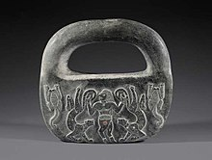](https://en.wikipedia.org/wiki/File:Chlorite_object_Jiroft,_Kerman_ca._2500_BCE,_Bronze_Age_I,_National_Museum_of_Iran.jpg)

[Master of animals](https://en.wikipedia.org/wiki/Master_of_animals) in [chlorite](https://en.wikipedia.org/wiki/Chlorite), Jiroft, Kerman ca. 2500 BC, Bronze Age I, [National Museum of Iran](https://en.wikipedia.org/wiki/National_Museum_of_Iran)

Writing system[[edit](https://en.wikipedia.org/w/index.php?title=Jiroft_culture&action=edit&section=4" \o "Edit section: Writing system)]

The inscription, discovered in a palace, was carved on a brick whose lower left corner only has remained, explained [Yusef Majidzadeh](https://en.wikipedia.org/wiki/Yusef_Majidzadeh" \o "Yusef Majidzadeh), head of the Jiroft excavation team.[[4]](https://en.wikipedia.org/wiki/Jiroft_culture#cite_note-presstv.ir-4)

"The two remaining lines are enough to recognize the [Elamite script](https://en.wikipedia.org/w/index.php?title=Elamite_script&action=edit&redlink=1)," he added.

"The only ancient inscriptions known to experts before the Jiroft discovery were cuneiform and hieroglyph," said Majidzadeh, adding that" The new-found inscription is formed by geometric shapes and no linguist around the world has been able to decipher it yet."

Archeologists have found many artifacts confirming the existence of a rich civilization dating back to the third millennium BC, during the 5 previous excavational phases.

The sixth phase of Jiroft excavations will focus on the temple and the sites where the tablets were found during previous phases.

Archeologists believe the discovered inscription is the most ancient script found so far and that the Elamite written language originated in Jiroft, where the writing system developed first and was then spread across the country.[[4]](https://en.wikipedia.org/wiki/Jiroft_culture#cite_note-presstv.ir-4) Other scholars[[5]](https://en.wikipedia.org/wiki/Jiroft_culture" \l "cite_note-5) have called the authenticity of the cyphers into question, suggesting they may be examples of several modern forgeries in circulation since the earlier looting[[6]](https://en.wikipedia.org/wiki/Jiroft_culture#cite_note-6) at the site.

**Accession Number:**

**LC Classification:**

**Date or Time Horizon:**

**Geographical Area:**

**Map:**

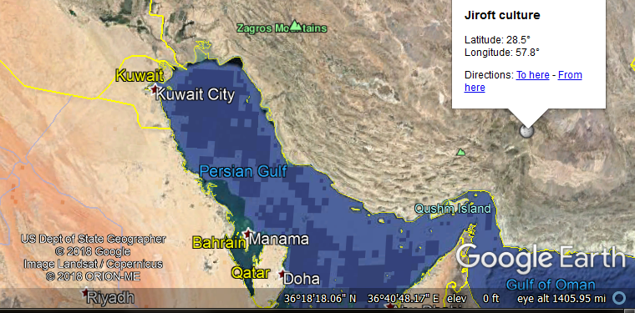

**GPS coordinates:**

**Cultural Affiliation:**

**Media:**

**Dimensions:**

**Weight:**

**Condition:**

**Provenance:**

**Discussion:**

**References:**

* *Jiroft, Fabuleuse Decouverte en Iran*, Dossiers Archeologica 287, October 2003.
* Yousef Mazidzadeh, *Jiroft earliest oriental civilization* (2004).
* O. White Muscarella, *Jiroft and "Jiroft-Aratta": A Review Article of Yousef Madjidzadeh, Jiroft: The Earliest Oriental Civilization*, Bulletin of the Asia Institute 15 (2005) 173-198.
* Andrew Lawler, *Ancient Writing or Modern Fakery?*, Science 3 August 2007: Vol. 317. no. 5838, pp. 588 – 589.
* Andrew Lawler, *Iranian Dig Opens Window on New Civilization*, Science 21 May 2004: Vol. 304. no. 5674, pp. 1096–1097.
* M.R. Maheri *The Early Civilizations Of Kerman* (تمدّن های نخستین کرمان), Markaze Kerman Shenasaee (2000), 1st edition, [ISBN](https://en.wikipedia.org/wiki/International_Standard_Book_Number) [964-6487](https://en.wikipedia.org/wiki/Special:BookSources/964-6487-21-1)

This chalice is set on a flat base, with the sides boldly carved in raised relief.

This chalice is decorated with a procession of 4 bulls 2 moving to the right and 2 to the left. This iconography is typical of the Late Uruk and Jemdet Nasr periods at the end of the fourth millennium BCE when cities were developing in Mesopotamia. Three-dimensional carving of bulls appears to suggest that the development of animal husbandry was becoming very important for the economies of individual city-states in the Mesopotamian delta where this chalice as found. Vessels of this type have been found in palaces or religious structures, which suggests that they had a ceremonial function. This appears confirmed by the axial placement of the Tree of Life placed in the procession so as to reflect the procession of life from it one of the major spiritual ideas of the time.

**Background:**  Uruk was dedicated to two great gods, An (or Anu) the sky god and Inanna or Semitic Ishtar, the goddess of love and procreation, whose vast temple complex E-Anna (the house of heaven) dominated the city. Stone vessels of this type - highly prized luxury goods made of imported stone and carved with great skill - date to the late Uruk period were often found in temples or palaces. Chalices such as this are thought to have been made for ceremonial use in temples (the mythical animals known from cylinder seals may be associated with cults espousing politicization of a region. Inanna's husband Dumuzi-Tammuz was closely associated with vegetation, flocks and cattle and the cult of the sacred marriage between them, with its associated rites designed to ensure productivity and fertility, originated at Uruk.  
For a similar stone bowl decorated with bulls see, J. Aruz (ed.), *Art of the First Cities*, exhibition catalogue, The Metropolitan Museum of Art, New York, 2003, p. 42, no. 12, for a stone bowl with bulls in relief in the Vorderasiatische Museum, Berlin, no. VA 10113; "The considerable work involved in creating stone vessels and the fact that the stone was imported gave them great value. While fragile ceramic vessels had to be continually replaced and therefore likely to reflect changes in taste ... stone vessels tended to be produced in a limited range of shapes and to be used for generations."

Appendix:

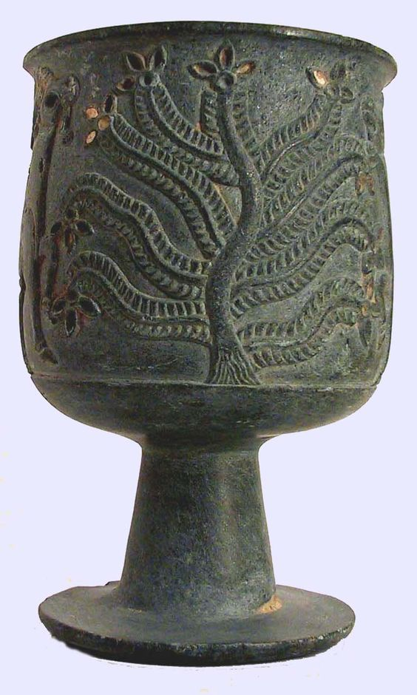b

jiroft, Iran - artifact decorated with palm tree tree of life; feathers

The **[Jiroft Civilization](http://en.wikipedia.org/wiki/Jiroft_civilization)** (Persian تمدن جيرفت) is a proposed [Early Bronze Age](http://en.wikipedia.org/wiki/Early_Bronze_Age) civilization of [Sistan](http://en.wikipedia.org/wiki/Sistan" \o "Sistan), [Iran](http://en.wikipedia.org/wiki/Iran) (fl. ca. [26th century BC](http://en.wikipedia.org/wiki/26th_century_BC)). It was proposed by Yousef Madjidzadeh in 2003 based on archaeological artefacts confiscated by Iranian authorities. White Muscarella (2005) expresses serious doubt in the validity of the “Jiroft Civilization” as an archaeological entity. The Jiroft site itself is of undisputed notability as a mid-3rd millennium city situated between the [Elamite civilization](http://en.wikipedia.org/wiki/Elamite_civilization) to the west and the [Indus Valley civilization](http://en.wikipedia.org/wiki/Indus_Valley_civilization) to the east.